Ex.no:4 | EXPLORATORY DATA ANALYSIS (EDA) – DATA INSPECTION, FILTERING, STATISTICAL ANALYSIS AND CORRELATION

Aim:

Algorithm:

Program:
import pandas as pd
import matplotlib.pyplot as plt
import seaborn as sns
# Import Dataset
df = pd.read_csv("diabetic_data.csv", na_values="?", low_memory=False)
# ==========================
# Dataset Inspection
# ==========================
print("===== FIRST FIVE RECORDS =====")
display(df.head())
print("\n===== SHAPE OF DATASET =====")
print(df.shape)
print("\n===== DATA TYPES =====")
print(df.dtypes)
print("\n===== SUMMARY =====")
display(df.describe())
# ==========================
# Filtering Data
# ==========================
# Patients staying more than 7 days
print("\n===== PATIENTS STAYING MORE THAN 7 DAYS =====")
long_stay = df[df["time_in_hospital"] > 7]
display(long_stay.head())
# Female Patients
print("\n===== FEMALE PATIENTS =====")
female = df[df["gender"] == "Female"]
display(female.head())
# ==========================
# Sorting Data
# ==========================
print("\n===== SORT BY NUMBER OF MEDICATIONS (DESCENDING) =====")
sorted_df = df.sort_values(by="num_medications", ascending=False)
display(sorted_df.head())
# ==========================
# Statistical Analysis
# ==========================
print("\n===== NUMBER OF MEDICATIONS STATISTICS =====")
print("Mean :", df["num_medications"].mean())
print("Median :", df["num_medications"].median())
print("Mode :")
print(df["num_medications"].mode())
print("Standard Deviation :", df["num_medications"].std())
print("\n===== DESCRIPTIVE STATISTICS =====")
display(df.describe())
# ==========================
# Grouping and Aggregation
# ==========================
print("\n===== AVERAGE HOSPITAL STAY BY GENDER =====")
gender_avg = df.groupby("gender")["time_in_hospital"].mean()
display(gender_avg)
# ==========================
# Correlation Analysis
# ==========================
print("\n===== CORRELATION =====")
corr = df[["time_in_hospital","num_lab_procedures","num_procedures","num_medications","number_outpatient","number_emergency","number_inpatient", "number_diagnoses"]].corr()
display(corr)
# ==========================
# Visualization 1
# ==========================
gender_avg.plot(kind="bar")
plt.title("Average Hospital Stay by Gender")
plt.xlabel("Gender")
plt.ylabel("Average Hospital Stay")
plt.show()
# ==========================
# Visualization 2
# ==========================
plt.figure(figsize=(8,5))
plt.scatter(df["num_lab_procedures"],df["num_medications"])
plt.title("Lab Procedures vs Number of Medications")
plt.xlabel("Lab Procedures")
plt.ylabel("Number of Medications")
plt.show()

Output: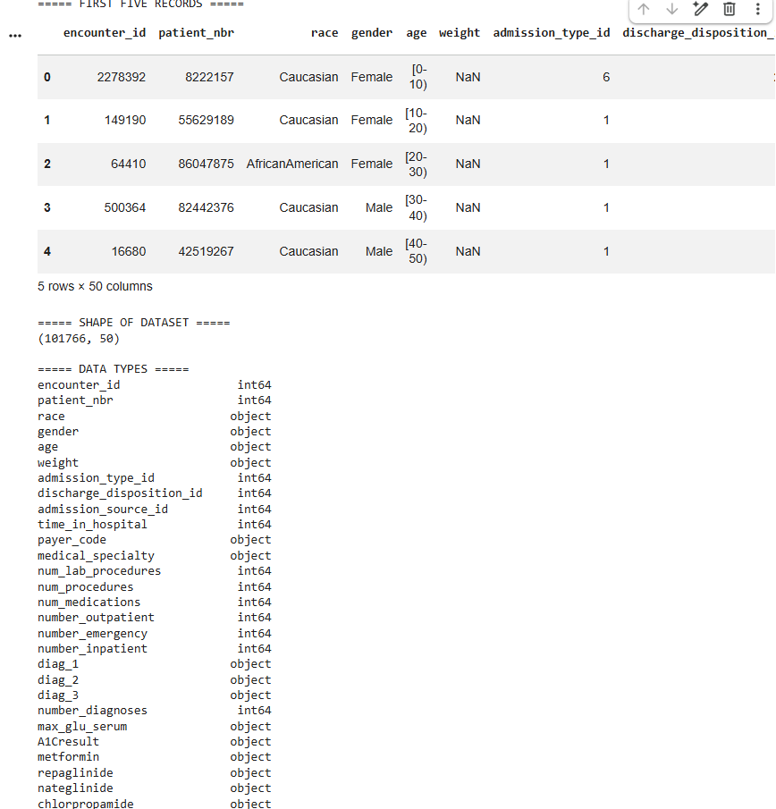
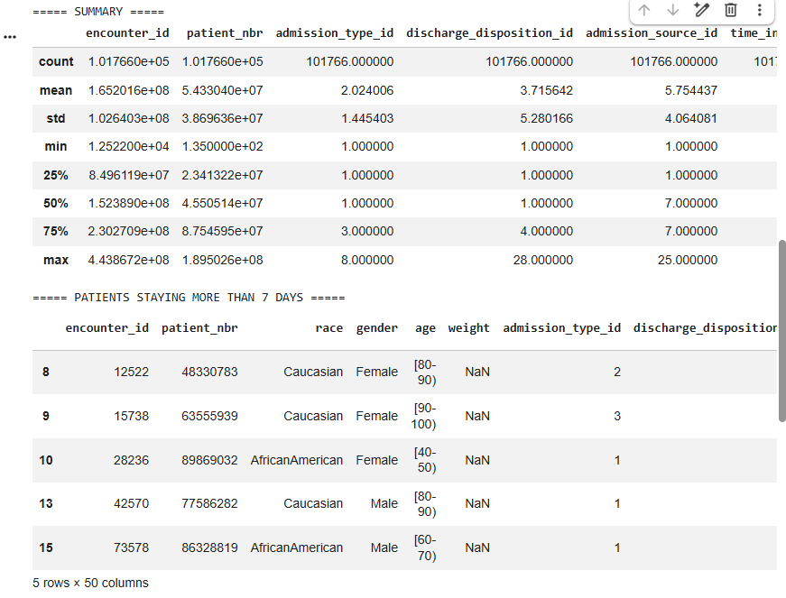
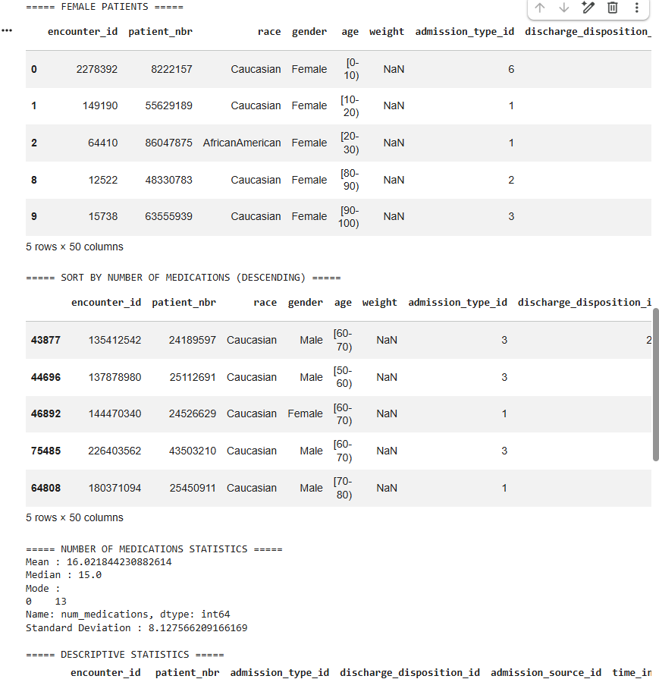

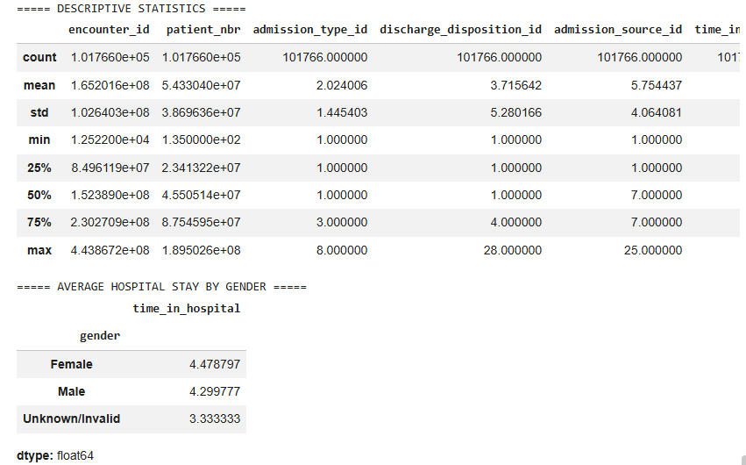
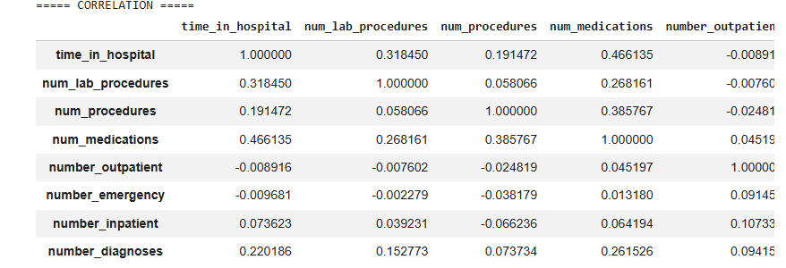
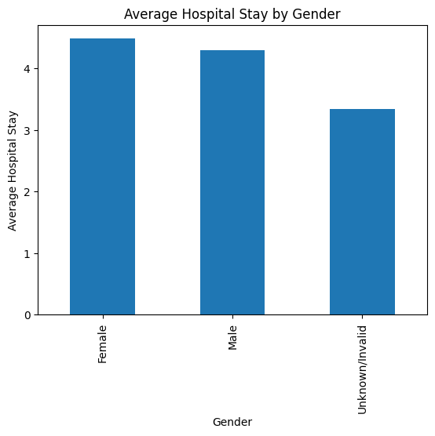

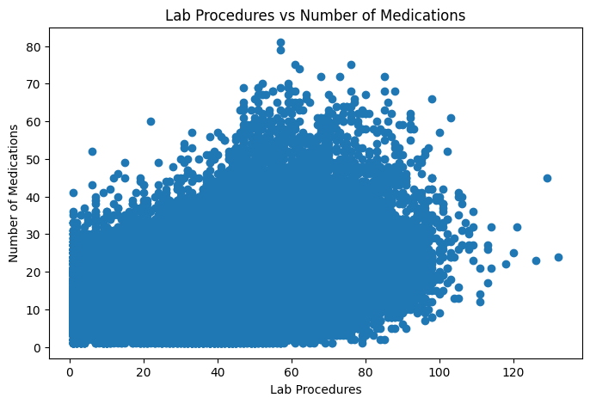

Result:

